Write Water Jug problem using python code

Aim :To solve the water jug problem using Python.

Procedure:
- Initialize the capacities of the two jugs.
- Fill, empty, or pour water between the jugs.
- Repeat the operations until the target amount is obtained.
- Display the sequence of steps.

Output:
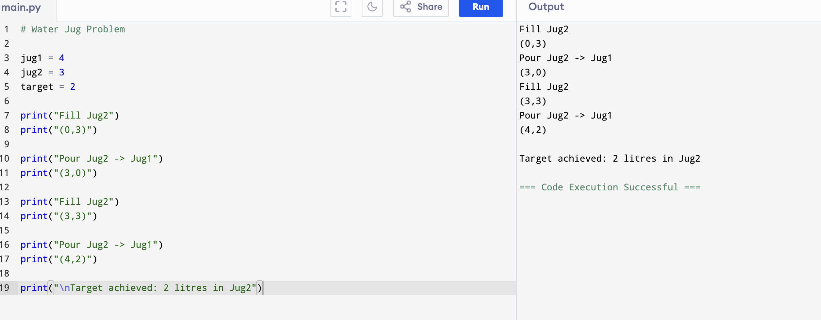

Result: Hence, the water jug problem has solved

